**Outlier Analysis using Scatter Plot**

1. **N : 10000+200, D : 2, K : 2**

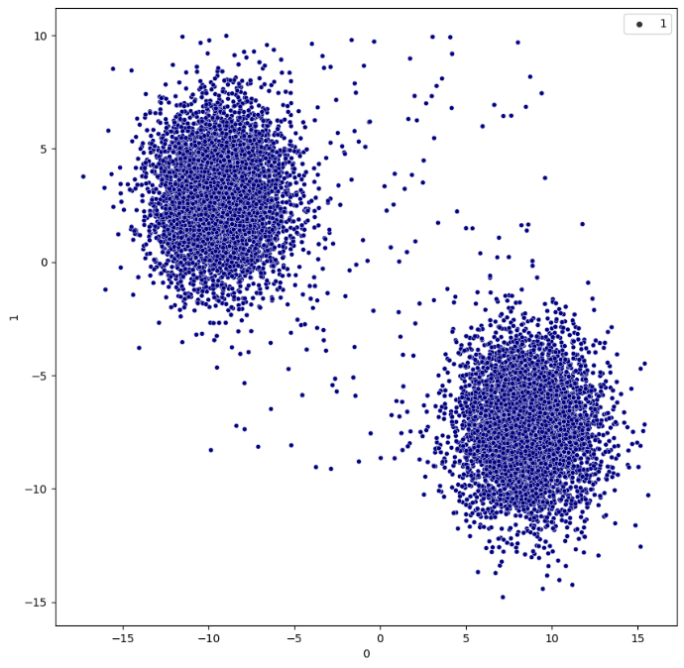 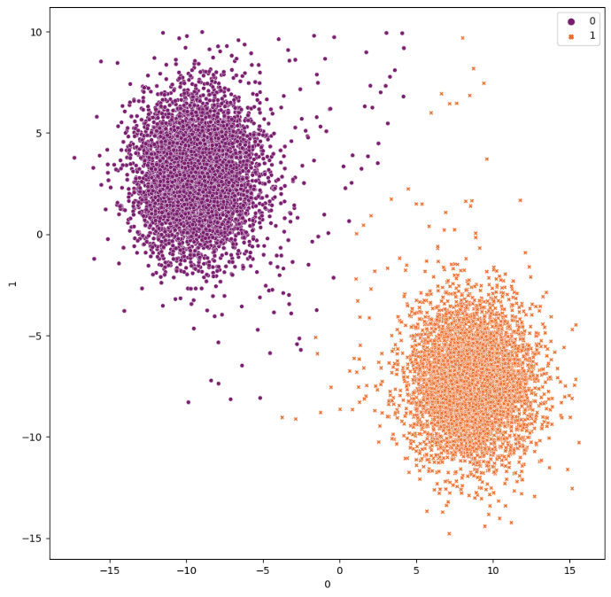

Actual Data Points Clusters obtained by KMeans

* **Isolation Forest**

Contamination = ‘auto’

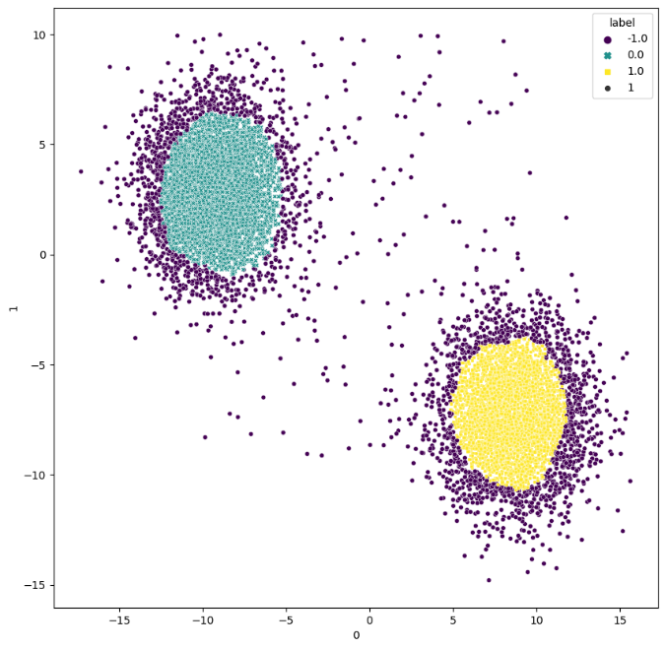 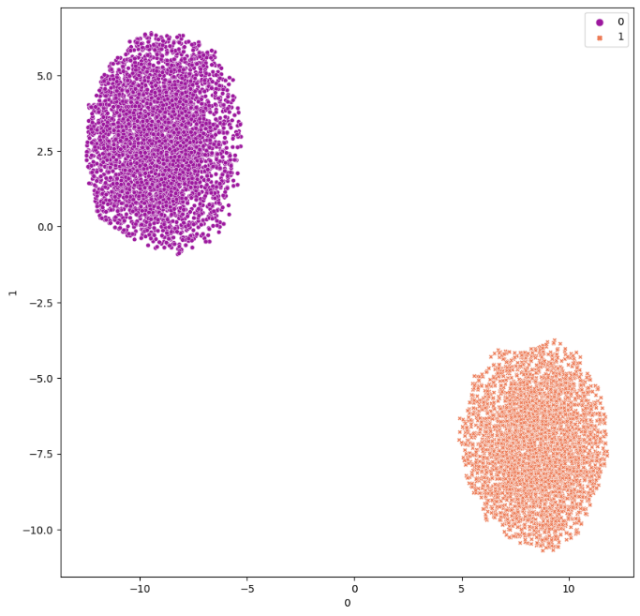

Obtained Outliers Clusters obtained after removing outliers

Contamination = 0.025

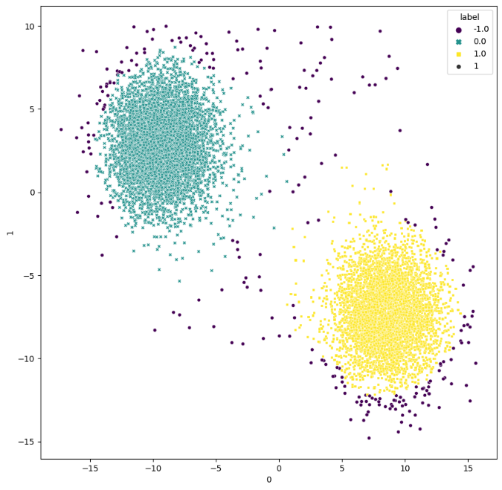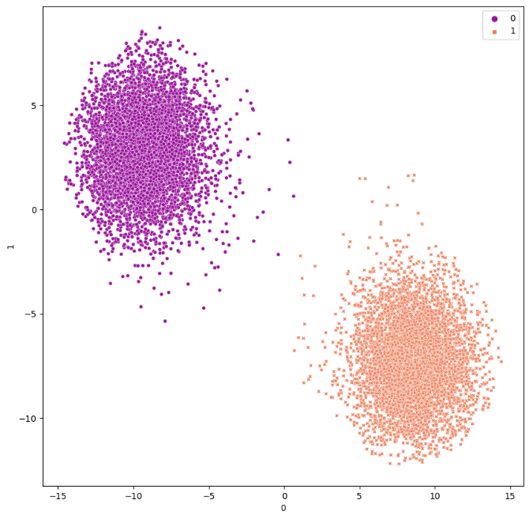

Obtained Outliers Clusters obtained after removing outliers

Contamination = 0.05

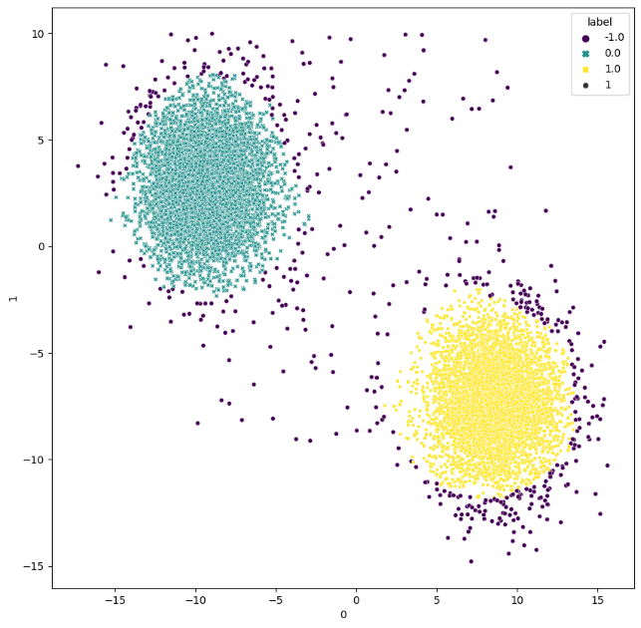 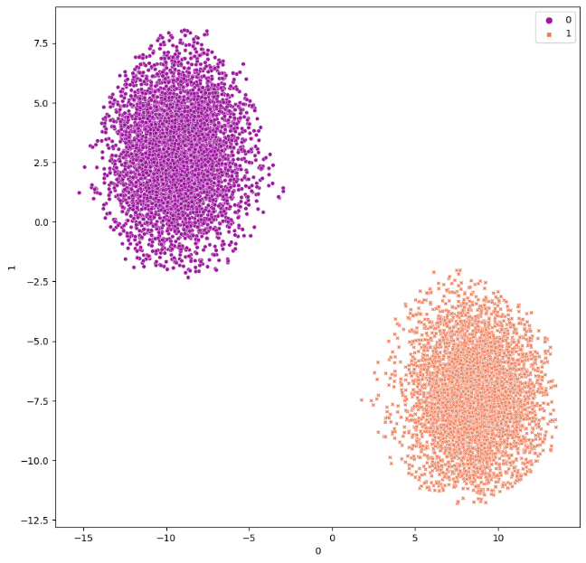

Obtained Outliers Clusters obtained after removing outliers

Contamination = 0.1

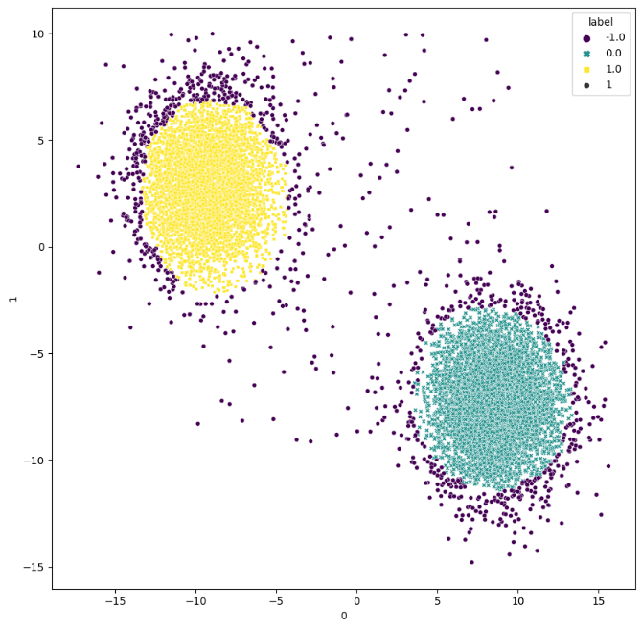 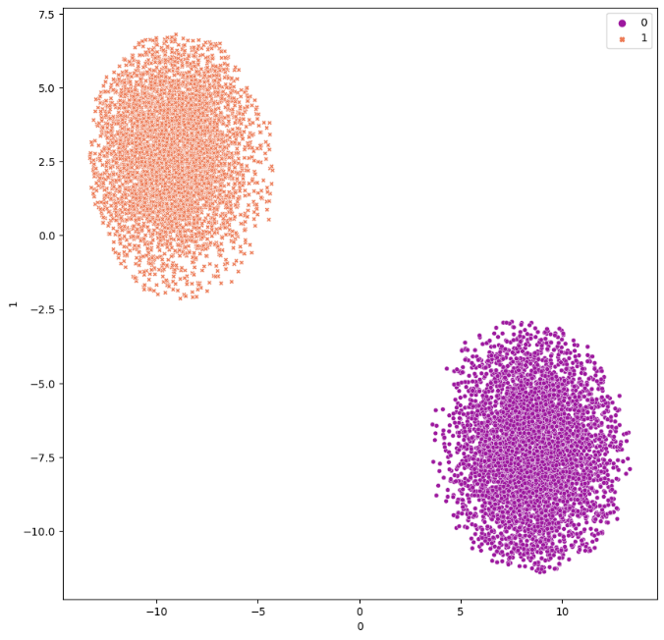

Obtained Outliers Clusters obtained after removing outliers

* **Local Outlier Factor**

Contamination = ‘auto’

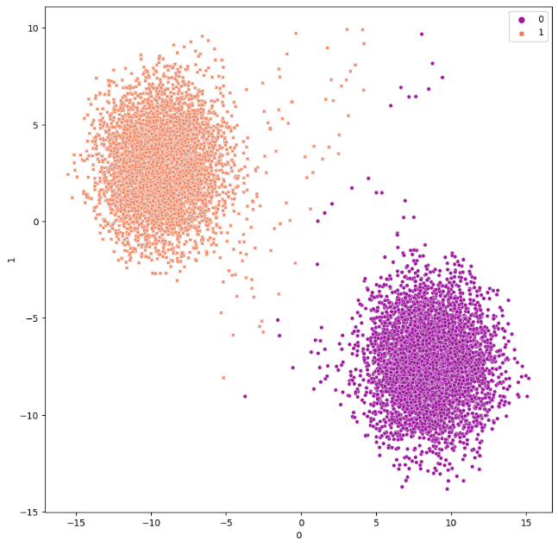 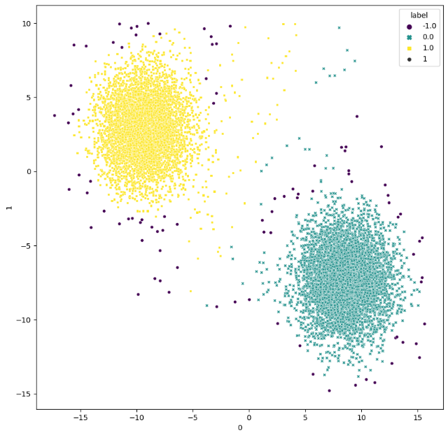

Obtained Outliers Clusters obtained after removing outliers

Contamination = 0.025

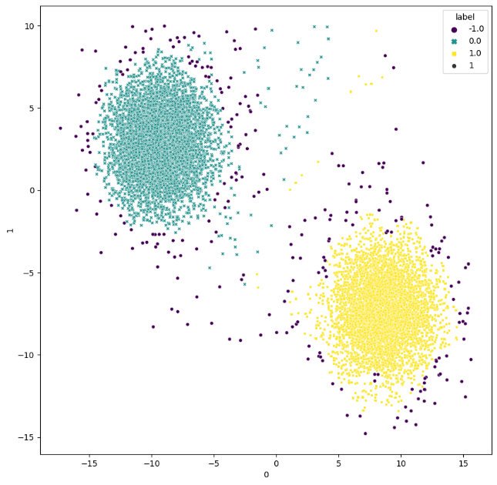 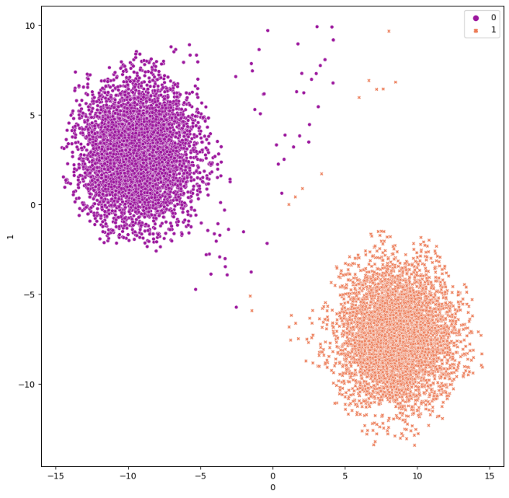

Obtained Outliers Clusters obtained after removing outliers

Contamination = 0.05

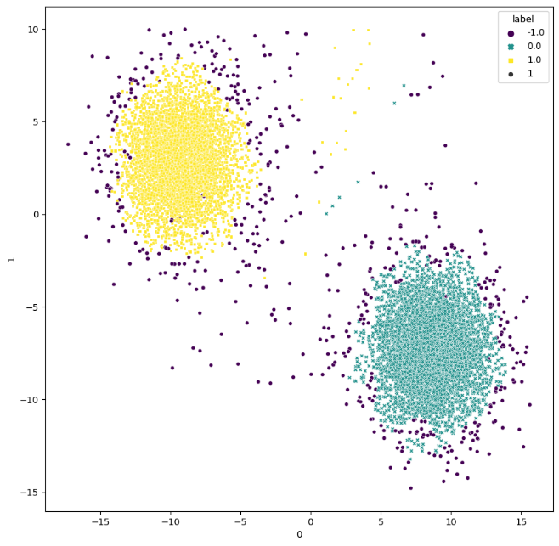 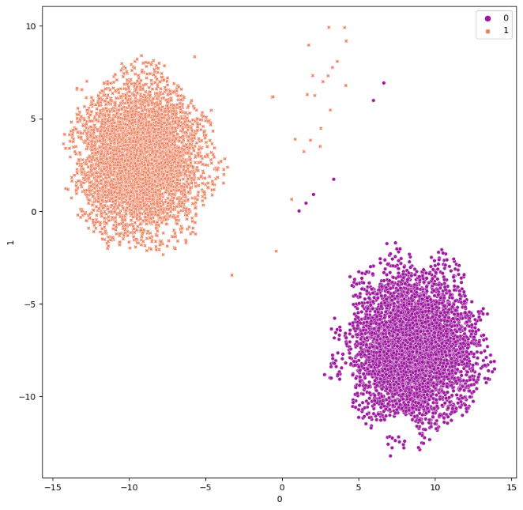

Obtained Outliers Clusters obtained after removing outliers

Contamination = 0.1

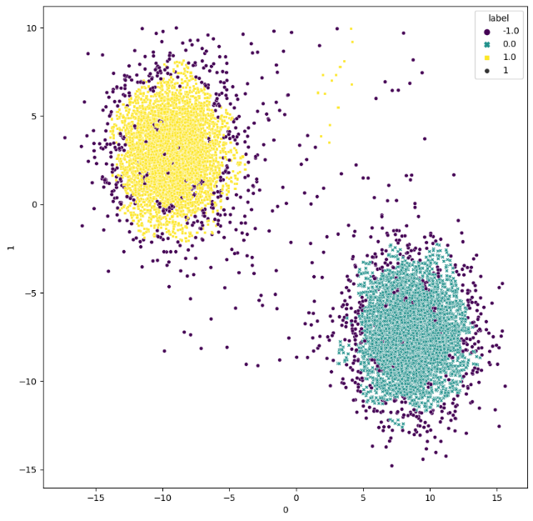 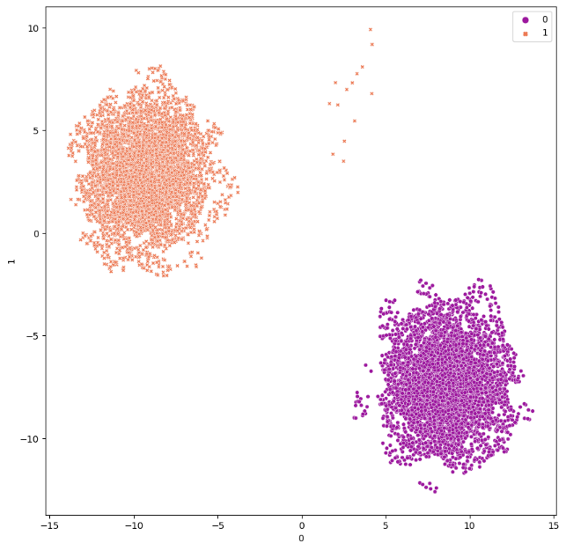

Obtained Outliers Clusters obtained after removing outliers

Contamination = 0.1, n_neighbors = 100

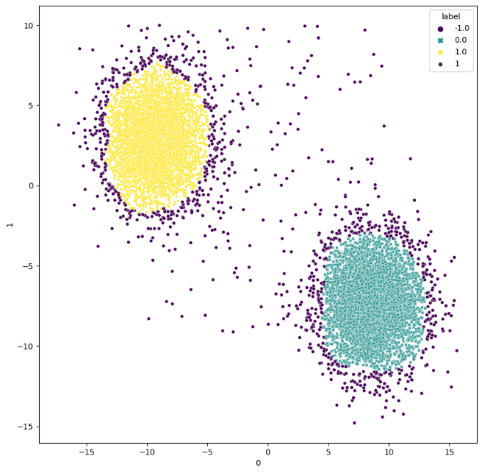 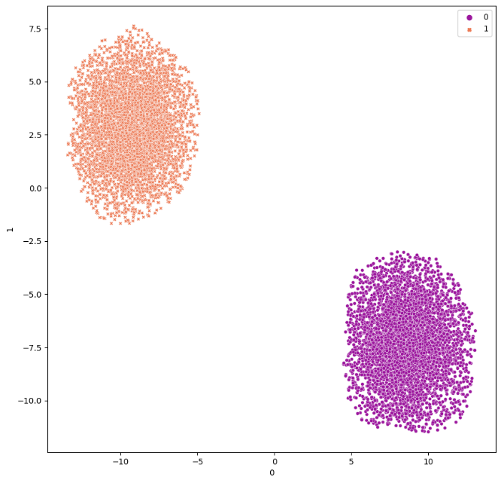

Obtained Outliers Clusters obtained after removing outliers

Contamination = ‘auto’, n_neighbors = 100

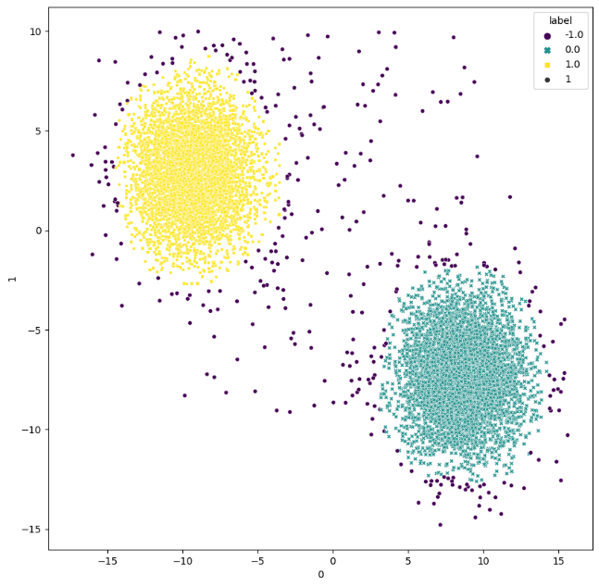 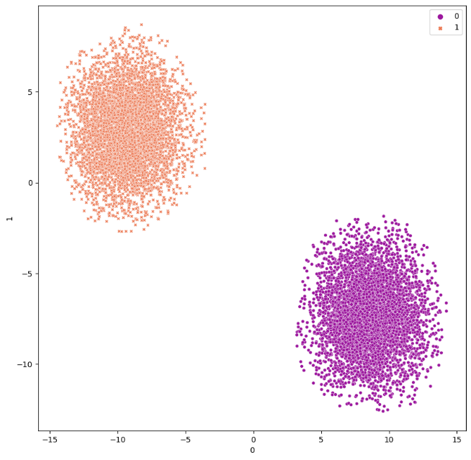

Obtained Outliers Clusters obtained after removing outliers

* **One Class SVM**

Nu = ‘auto’

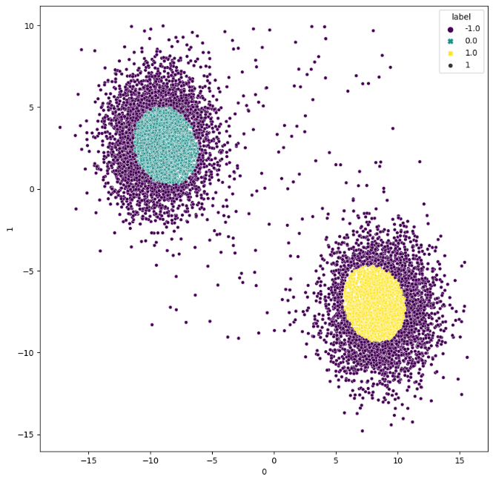 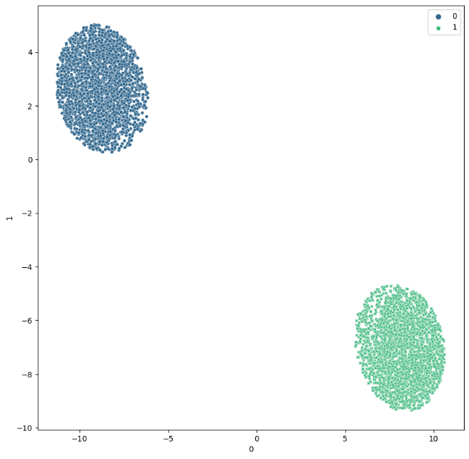

Obtained Outliers Clusters obtained after removing outliers

Nu = 0.025

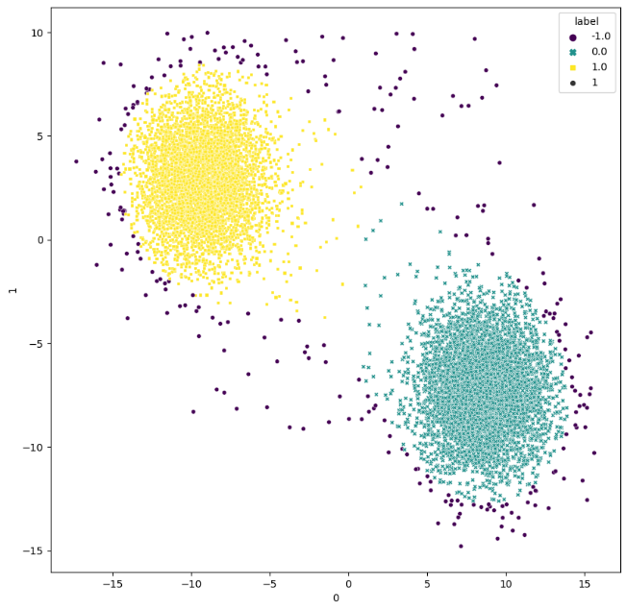 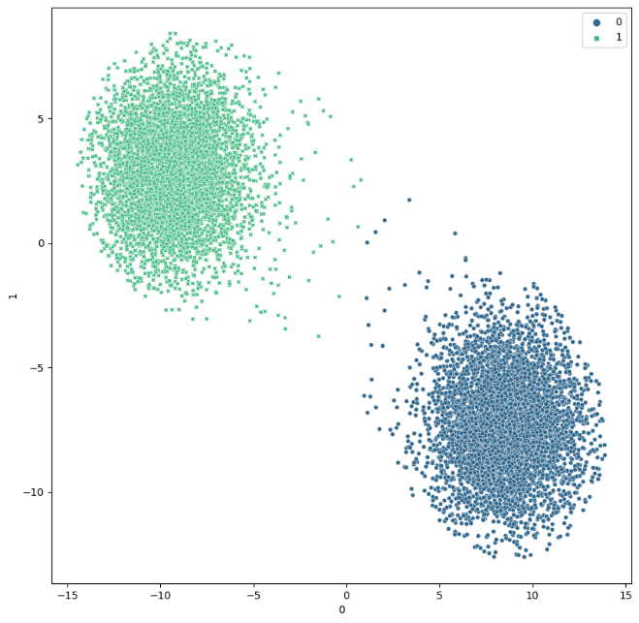

Obtained Outliers Clusters obtained after removing outliers

Nu = 0.05

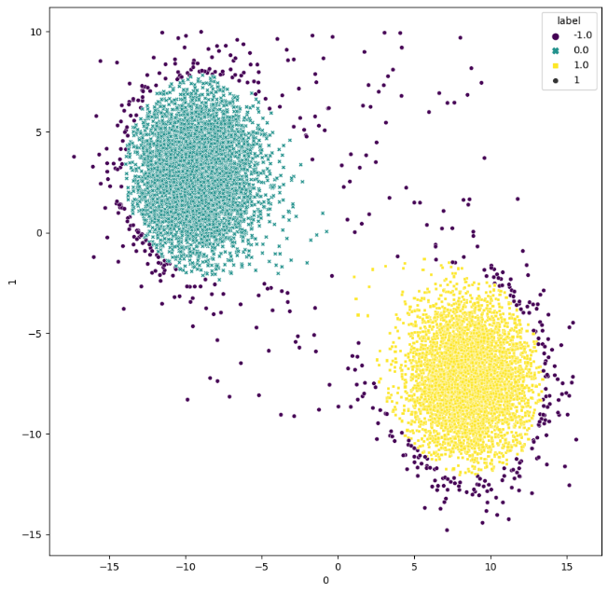 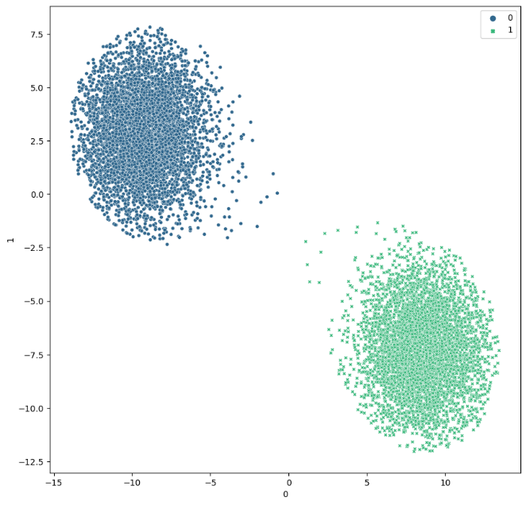

Obtained Outliers Clusters obtained after removing outliers

Nu = 0.1

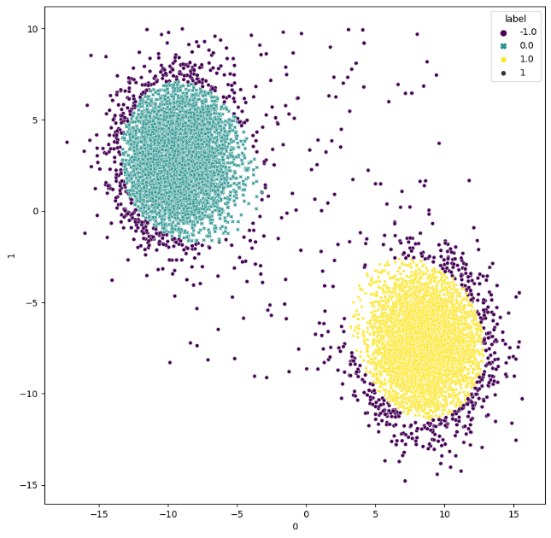 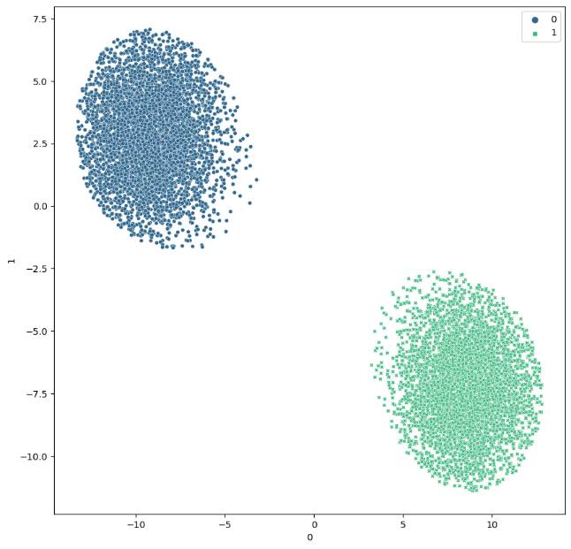

Obtained Outliers Clusters obtained after removing outliers

1. **N : 10000+400, D : 2, K : 2**

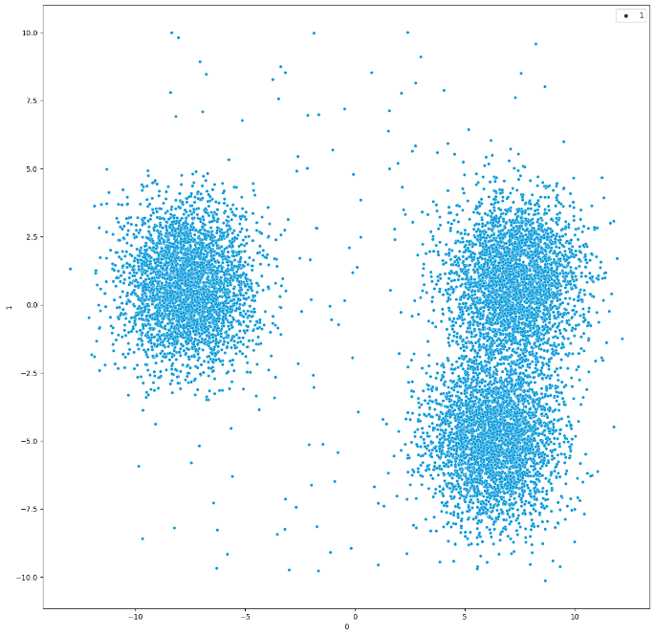 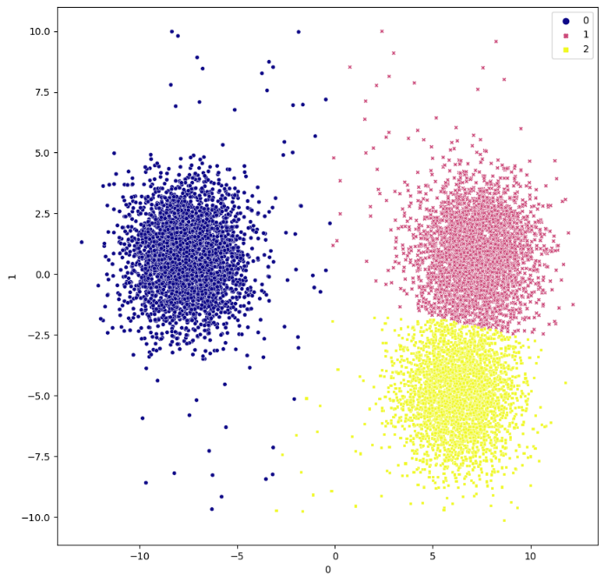

Actual Data Points Clusters obtained by KMeans

* **Isolation Forest**

Contamination = ‘auto’

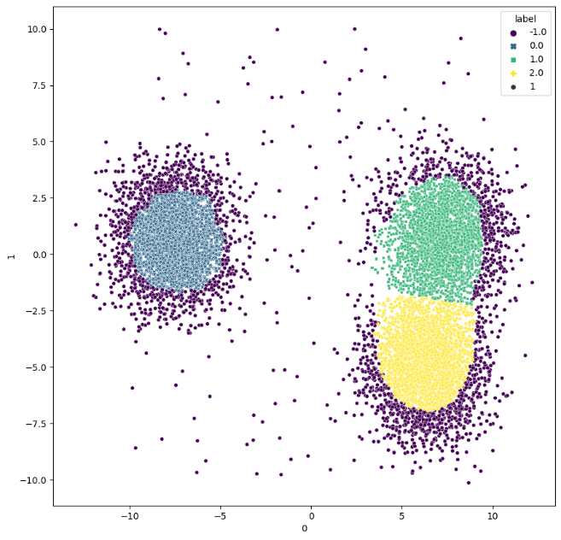 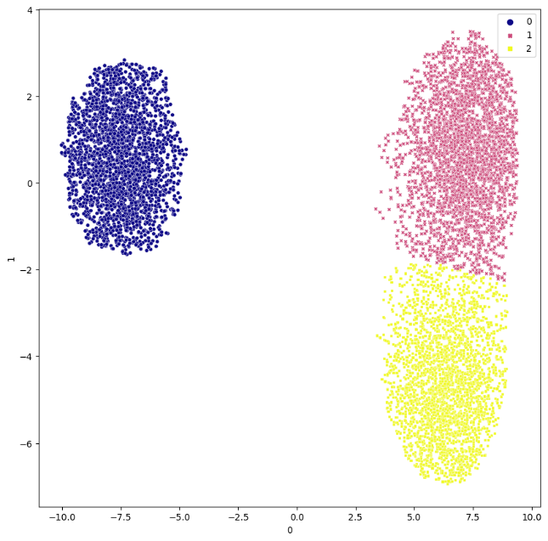

Obtained Outliers Clusters obtained after removing outliers

Contamination = 0.025

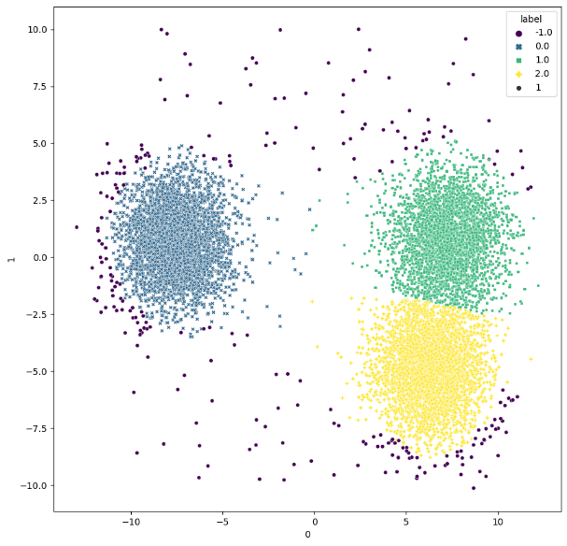 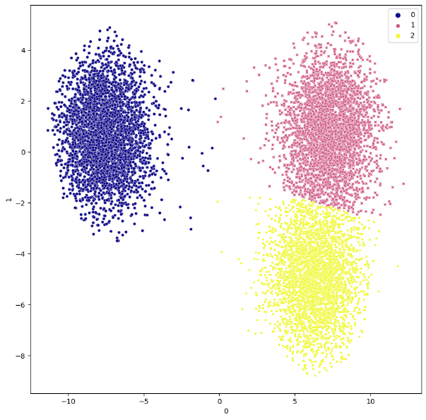

Obtained Outliers Clusters obtained after removing outliers

Contamination = 0.05

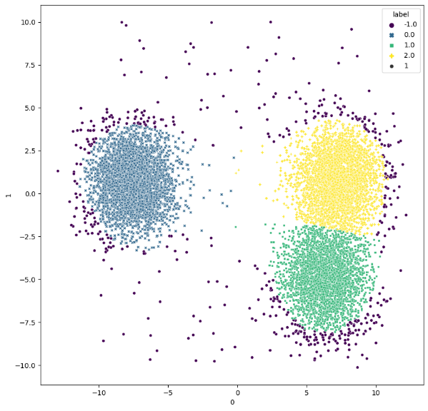 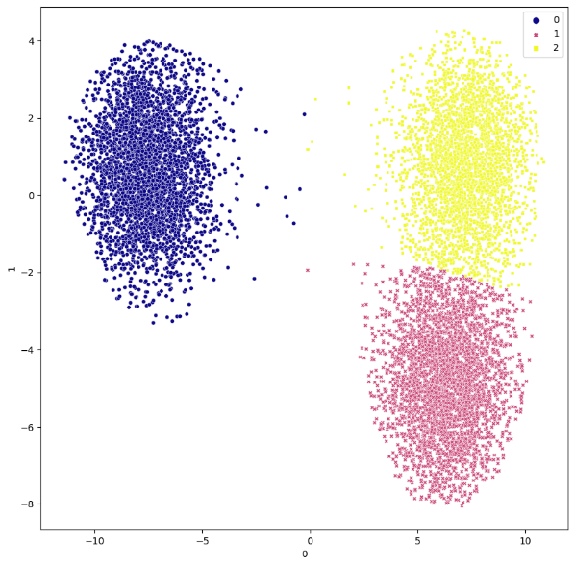

Obtained Outliers Clusters obtained after removing outliers

Contamination = 0.1

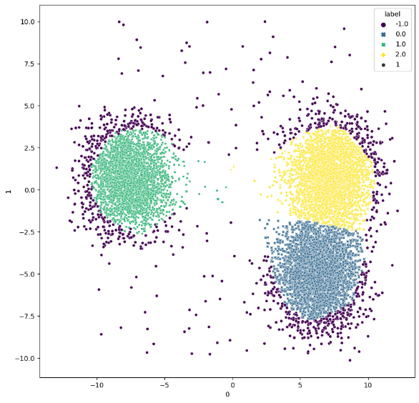 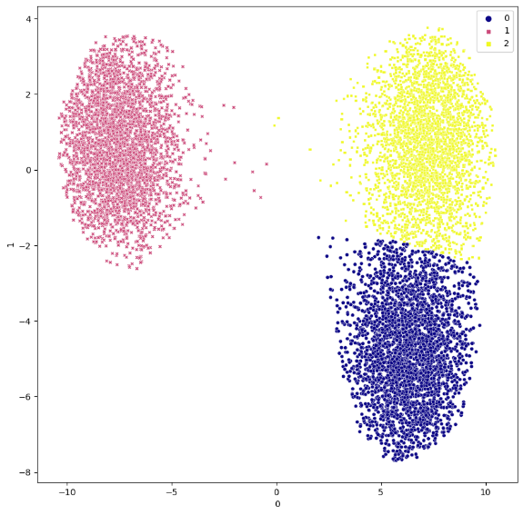

Obtained Outliers Clusters obtained after removing outliers

* **Local Outlier Factor**

Contamination = ‘auto’

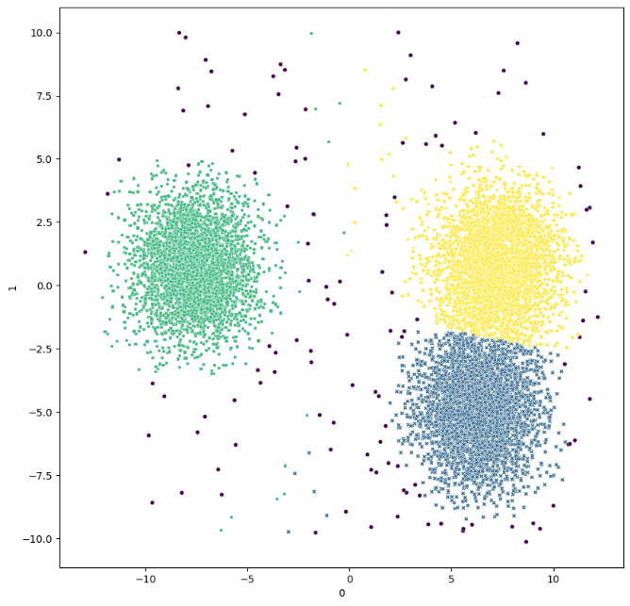 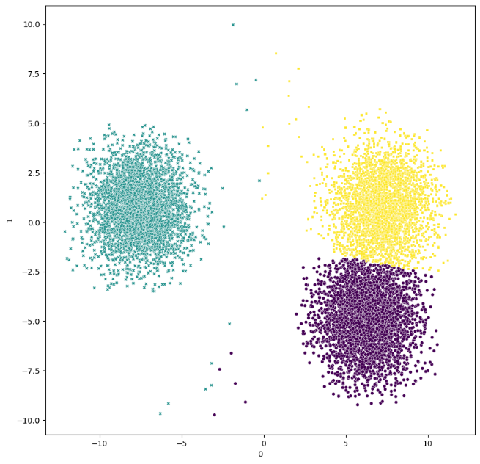

Obtained Outliers Clusters obtained after removing outliers

Contamination = 0.025

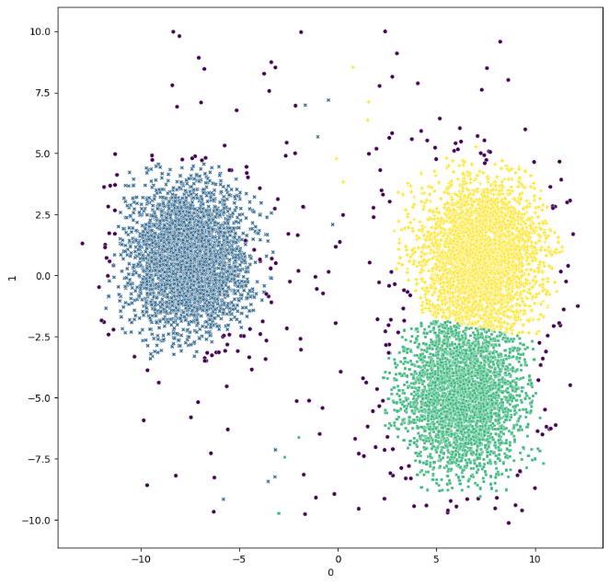 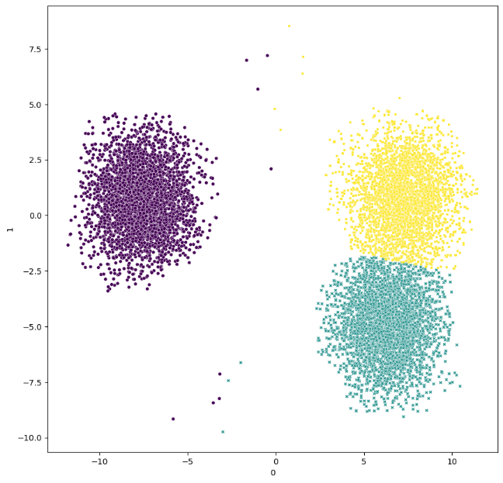

Obtained Outliers Clusters obtained after removing outliers

Contamination = 0.05

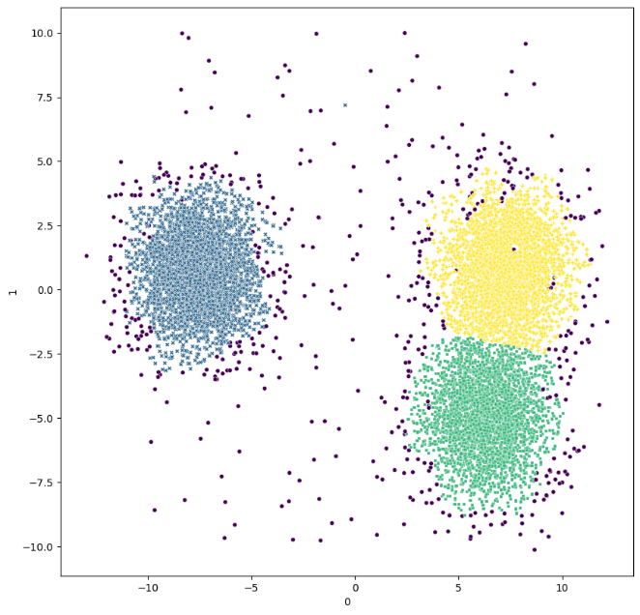 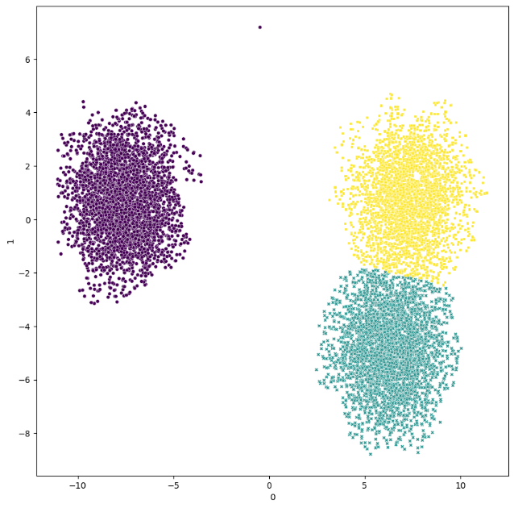

Obtained Outliers Clusters obtained after removing outliers

Contamination = 0.1

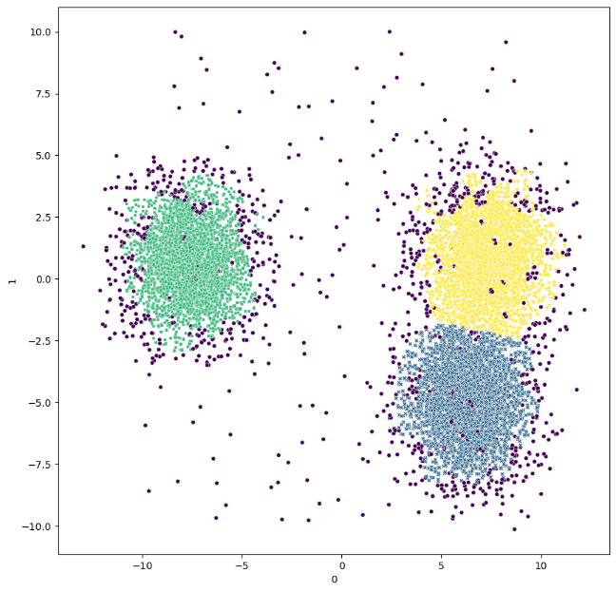 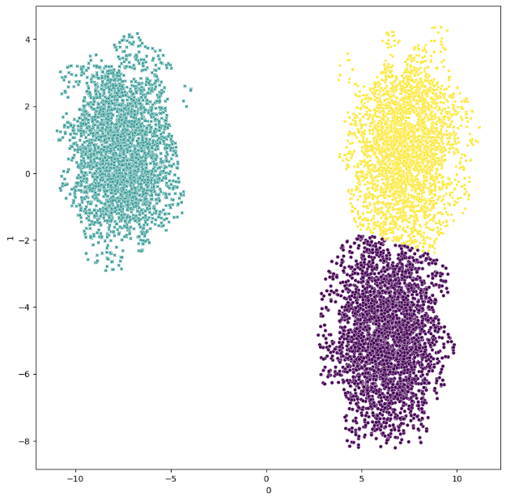

Obtained Outliers Clusters obtained after removing outliers

Contamination = 0.05, n_neighbors = 100

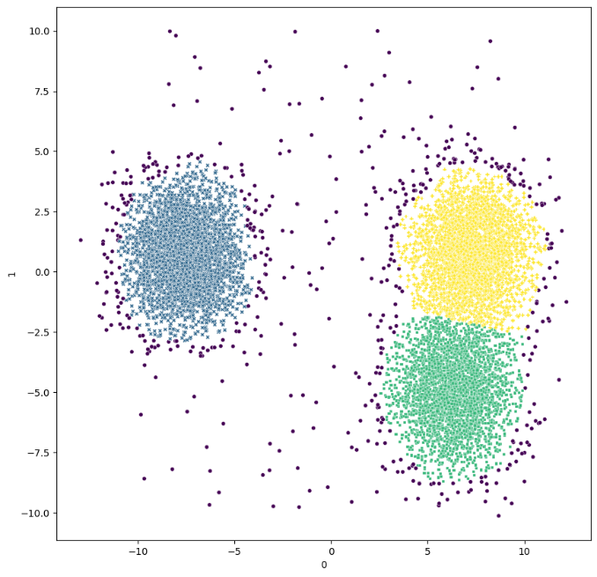 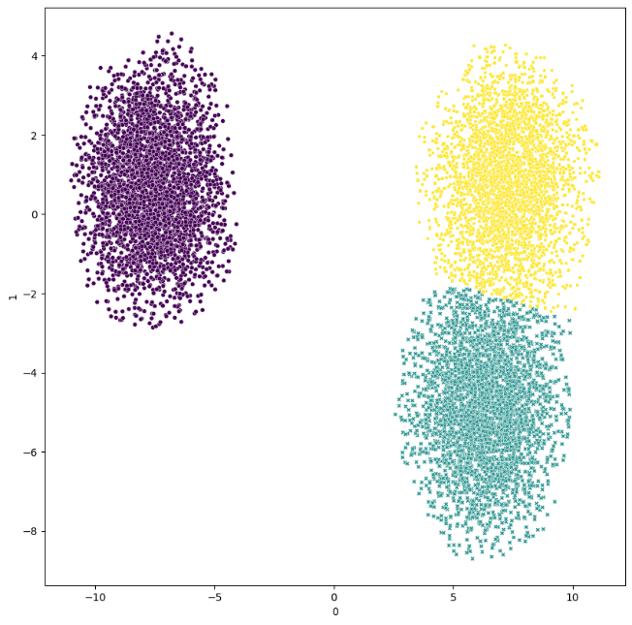

Obtained Outliers Clusters obtained after removing outliers

Contamination = 0.1, n_neighbors = 100

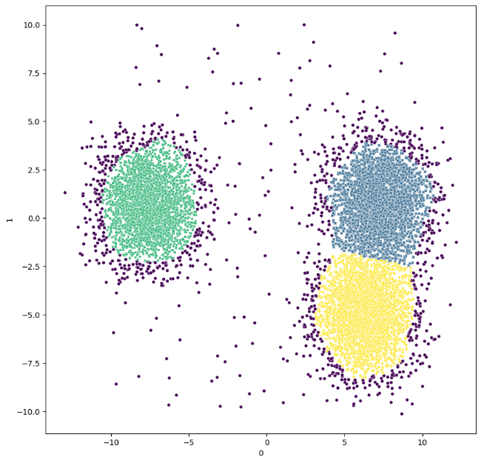 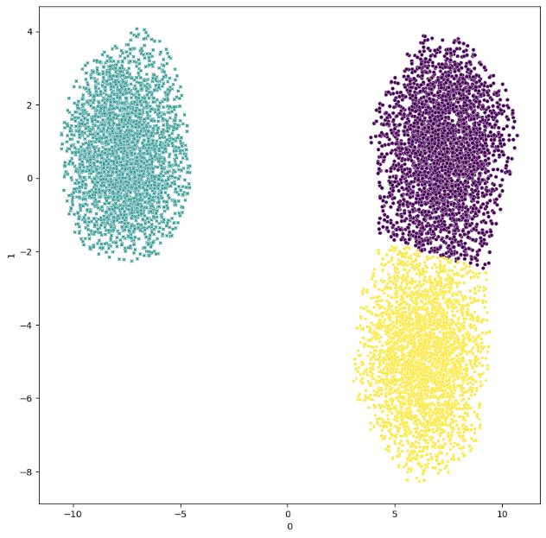

Contamination = ‘auto’, n_neighbors = 100

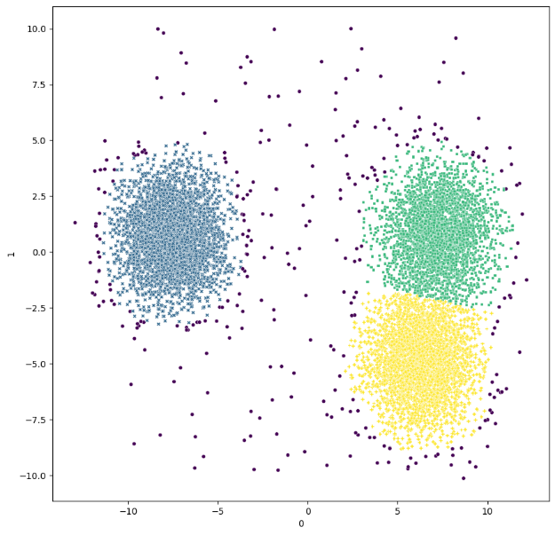 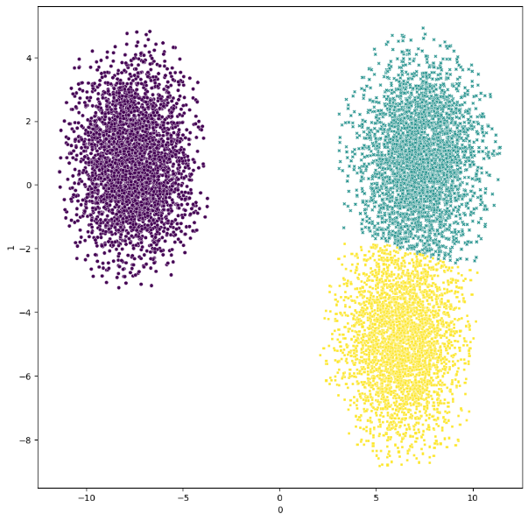

Obtained Outliers Clusters obtained after removing outliers

* **One Class SVM**

Nu = ‘auto’

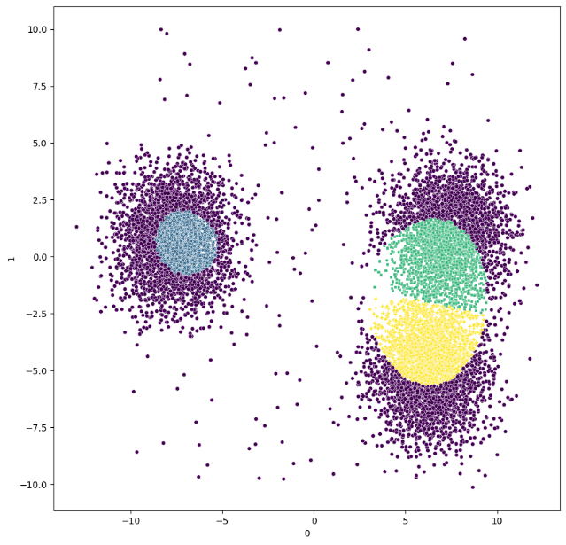 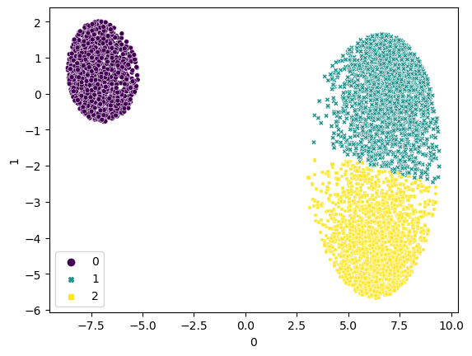

Obtained Outliers Clusters obtained after removing outliers

Nu = 0.025

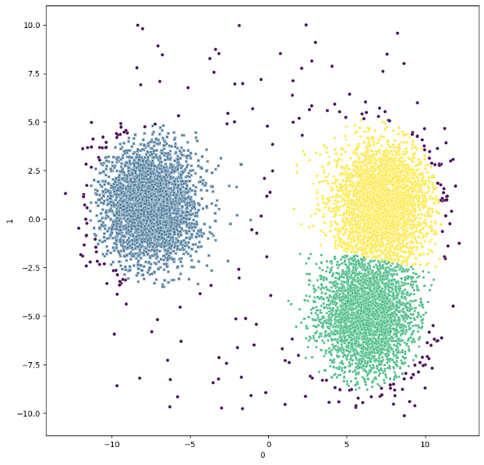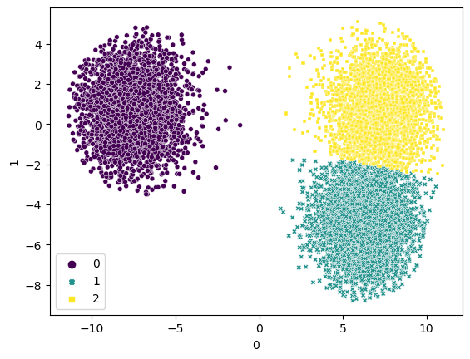

Obtained Outliers Clusters obtained after removing outliers

Nu = 0.05

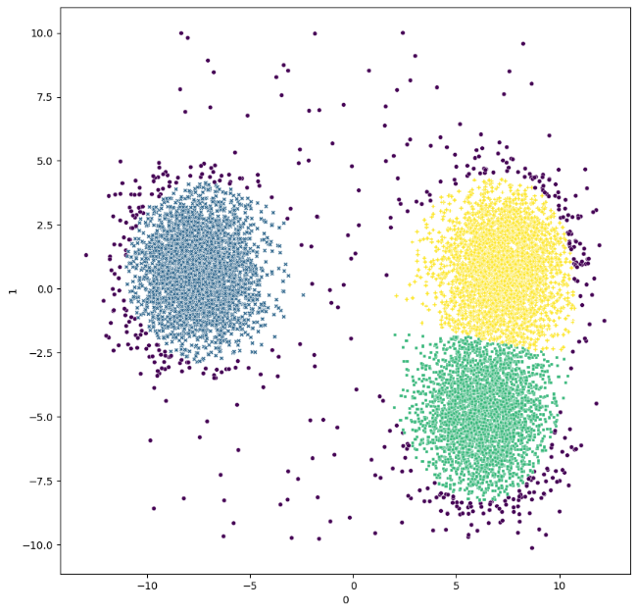 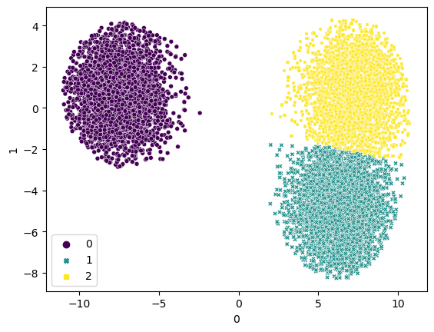

Obtained Outliers Clusters obtained after removing outliers

Nu = 0.1

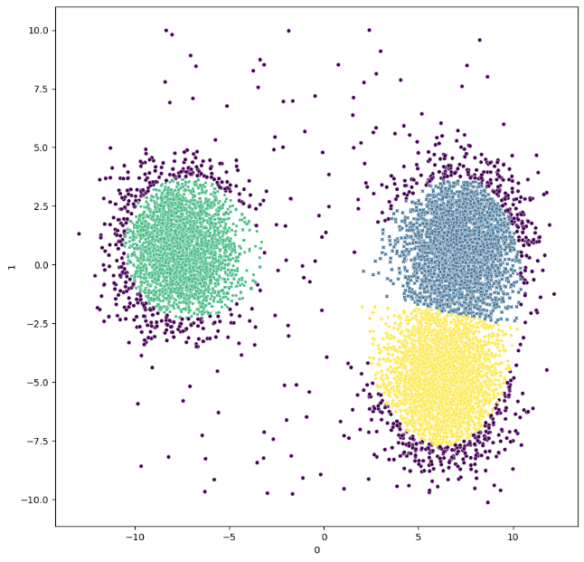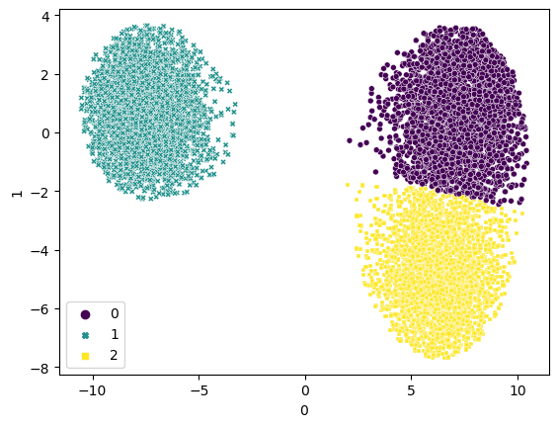

Obtained Outliers Clusters obtained after removing outliers